**HashiCorp Vault:** Vault is a tool developed by HashiCorp that provides a centralized and secure way to manage sensitive information such as secrets, passwords, and encryption keys. It is commonly used in cloud and containerized environments to secure and manage access to various resources.

Installation: <https://developer.hashicorp.com/vault/tutorials/getting-started/getting-started-install>

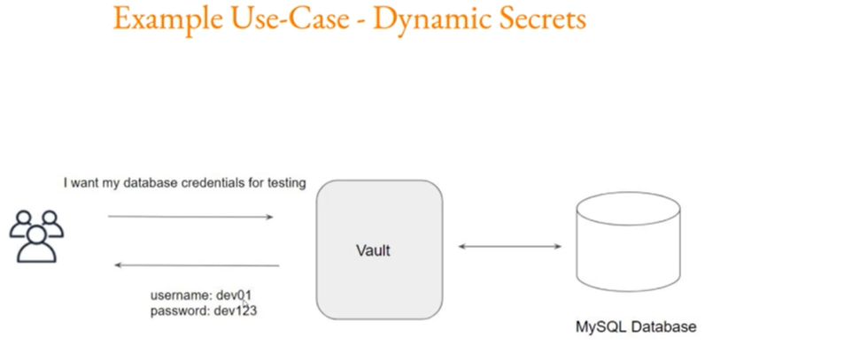

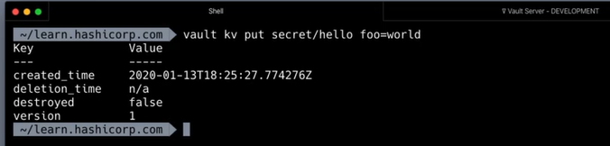

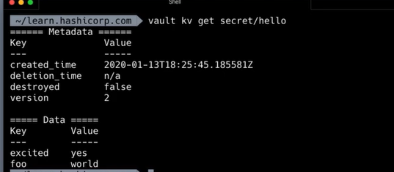



HashiCorp Vault is a popular tool for managing secrets and sensitive data in a secure manner. Integrating HashiCorp Vault with Kubernetes allows you to centralize and manage secrets for your applications running in Kubernetes clusters. Here's an overview of how you can manage secrets in Kubernetes using HashiCorp Vault:

**1. Install HashiCorp Vault:**

* Set up and install HashiCorp Vault in your infrastructure. You can deploy Vault as a standalone server or in a highly available configuration.

**2. Initialize and Unseal Vault:**

* Initialize Vault to set up the initial configuration and generate the unseal keys. Unseal Vault using the generated keys to make it operational.

**3. Enable Kubernetes Auth Method:**

* Configure Vault to use Kubernetes as an authentication method. This allows applications running in Kubernetes to authenticate with Vault using their service account tokens.

bash

vault auth enable kubernetes

**4. Create Kubernetes Service Account for Vault:**

* Create a Kubernetes service account for Vault and bind it to a role with the necessary permissions. This allows Vault to authenticate and authorize with the Kubernetes cluster.

bash

kubectl create serviceaccount vault

kubectl apply -f vault-cluster-role.yaml

**5. Configure Vault Policies:**

* Define Vault policies that specify which secrets and operations are allowed for different entities (users, applications).

bash

vault policy write my-policy - <<EOF

path "secret/data/my-app/*" {

capabilities = ["read", "list"]

}

EOF

**6. Create Kubernetes Auth Role:**

* Configure a role in Vault that maps Kubernetes service accounts to Vault policies.

bash

vault write auth/kubernetes/role/my-role \

bound_service_account_names=vault \

bound_service_account_namespaces=default \

policies=my-policy \

ttl=1h

**7. Inject Vault Secrets into Pods:**

* Use tools like the Vault Agent Injector or sidecar containers to inject Vault secrets into your Kubernetes pods.

**8. Dynamic Secrets:**

* Leverage Vault's dynamic secrets feature to generate short-lived credentials for databases and other services. This enhances security by reducing the exposure of long-lived credentials.

**9. Renewal and Rotation:**

* Set up renewal and rotation policies for secrets to ensure that they are regularly updated and remain secure.

**10. Monitoring and Auditing:**

* Enable Vault's auditing features to track and monitor access to secrets. Ensure that logs are stored securely and monitored for any suspicious activity.